
CC-215-L: Database Systems Lab

Faculty of Computing & Information Technology

BS(SE) Morning - Fall 2023, Semester Spring 2025
LAB – 02
The objective of this lab is to:
- DISTINCT
- ORDER BY
- NVL
- NUMBER FUNCTIONS
- CHARACTER FUNCTIONS
- DATE FUNCTIONS
- CONVERSION FUNCTIONS

Course & Lab Instructor: Dr. Asif Sohail
Hope you are fine and feeling yourself comfortable and exciting to play with Structured Query Language (SQL) in this first lab.
You have been taught in the lecture about SQL and query writing. Why not to get all what you have learned with a hands-on experience? So, let’s Start!
Allowed time: 1.5 hours
Note: Do follow these instructions while you are sitting in the lab and performing the tasks.
- Gossips are not allowed. So be gentle and do what you know. The lab is not to deduct your sessional marks but to prepare you to achieve good marks in quizzes, mids and finals and finally have good grades. So, try to perform all your tasks in time and at your own.
- Teacher assistants are for your help, so be nice with them. Respect them as they are teaching you. Raise your hands if you have some problem and need help from TA. Avoid calling them by raising your voice and disturbing the environment of Lab.
- You must revise the content of the past lectures before starting the lab, it will help you resolve most of your general queries and give you the confidence that you can do it.
- Evaluation will be considered final and you cannot debate for the marks. So, focus on performing the tasks when the time is given to you.
- TA may deduct your marks for any kind of ill-discipline or misconduct from your side.
- Finally, pray before you start. And, Best of Luck!
- Kindly paste the query as well as result table screenshot as a result of each task
Sample:
Display All the Employees from emp table
Solution:
Select * from emp
EMPNO | ENAME | JOB | MGR | HIREDATE | SAL | COMM | DEPTNO
7369 | SMITH | CLERK | 7902 | 12/17/1980 | 800 | - | 20
7499 | ALLEN | SALESMAN | 7698 | 02/20/1981 | 1600 | 300 | 30
7521 | WARD | SALESMAN | 7698 | 02/22/1981 | 1250 | 500 | 30
7566 | JONES | MANAGER | 7839 | 04/02/1981 | 2975 | - | 20
7654 | MARTIN | SALESMAN | 7698 | 09/28/1981 | 1250 | 1400 | 30

Task 01: [10 Marks]
- List the first 3 letters of ENAME, DEPTNO, and JOB of the table EMP.
- Find out all the employees who work as manager. Use ‘manager’ in where clause NOT ‘MANAGER’.
- LIST jobs of all employees with all letters ‘S’ removed from the beginning of their jobs.
- Display the 1-day salary of all employees without decimals.
- Display first 2 and last 2 letters of employees’ name within a single column named “formatted name”
- Find out the last day of this month with column of proper name.
- Display the salary of all employees in format ‘$20,000.00’ who work as managers.
- Display the employee Number of Salesman in format ‘7,3,9,6’.
- Using SQL statement find out how many months have passed since the day you were born until today. Name the column ‘Month’s Old’
- Display the names and hire date of employees who are either clerks or analysts. The hire date should be displayed in the format ‘DECEMBER, 17 1980’.
Task 02: [20 Marks]
- LIST ename, job, sal, and comm of all employees display 100 where comm is null.

- Display ename,job,sal and hiredate of all employees use ‘A’ in Place of ‘S’ in all strings.
- Display the output in the following format using CONCAT function. The JOB with NULL values should be substituted by ‘ROVER’. <ENAME> is a <JOB> hired in <YYYY>

- Count Number of A’s in the name of each employee.
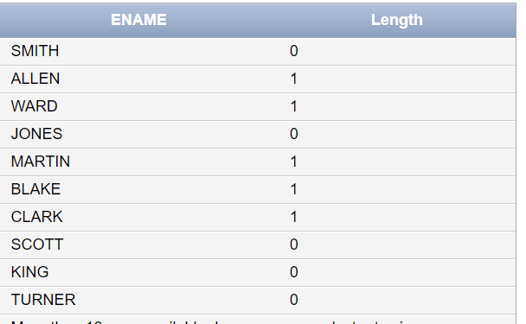

- Use a date function to find out first date of current year and the first date of this month. Display each of two in columns with names as ‘1st Date of Year’ and ‘1st Date of Month’.
- List Employees in Ascending Order of Name Length, But Sort Salaries in Descending Order
- Calculate the rounded salary for employees who earn more than 4000
- Display employee names along with their name length and the last character of their name.
- Generate an email address for each employee in the format <ename>@company.com, and a password consisting of their name’s first three letters + last three letters + job length.

Output:
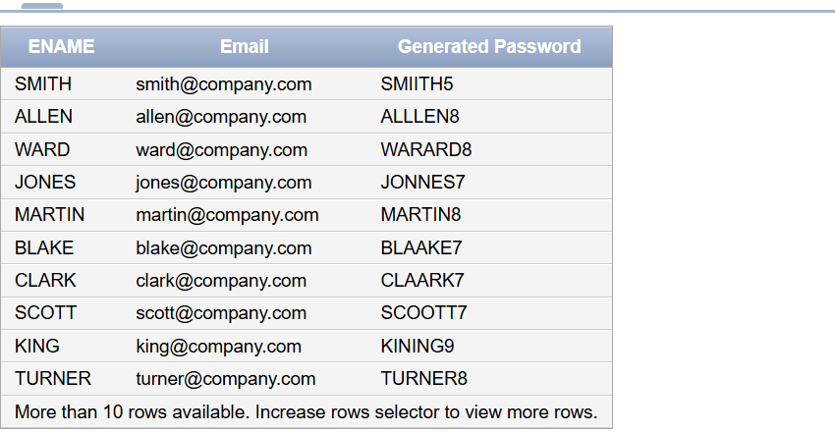

- Create a Fun Employee Nickname
Format:
- Nickname → First letter of ename + Last letter of ename + First 2 letters of job + @coolteam.com
- Encrypted Employee Name → Shift each letter forward by 1 (A → B, B → C, etc.)
Output:
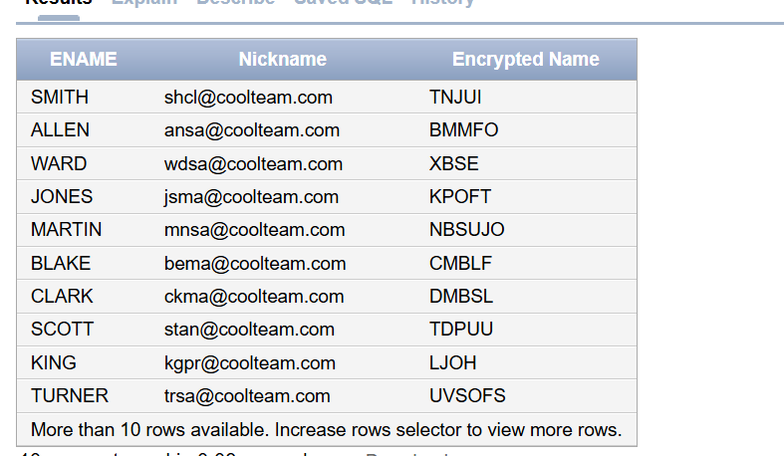

Task 03: [15 Marks]
- finds the employees hired in the last 90 days and calculates the number of days since they were hired
- Find the Day Name & Number of Days Since Each Employee Was Hired
- Convert Salary into Binary Representation
- Convert employee salaries to words (e.g., 4500 → ‘Four Thousand Five Hundred’) and show them.
- A full moon occurs every 29.53 days. Find employees who were hired on a full moon day.
Task 04: [5 Marks]
1. Viva Question

